**Pin Based Home Security**

To secure your home, office from unwanted visitors

By Farhan Sadick Zawad, , Touhidur Rahaman, , Sohel Aman Khan, Ahmad Rahman Farabi

CSE Department

BRAC University

***Abstract:* To prevent unwanted visitors to enter or to restrict access to our homes or offices, we needed a full proof system. Hence, comes our pin based home security. This pin based home security uses a fixed pin code to let someone enter or disallows, if it is otherwise. There are also other functionalities like the temperature of the house, motion detection, the amount of gas is present in the room, and buzzers are added. The design of this project is kept very simple so that anyone can use to secure their home and other accommodates. The cost is also kept very small to ensure that everyone can acquire or make it by themselves.**

***Keywords-* Arduino Mega 2560, configurations, wires, breadboard, LED.**

1. INTRODUCTION

To ensure security for homes and other accommodates this project is developed. The cost of this project is kept very low so that everyone can afford this system. This system maintains a strong security system as well as it ensures the safety of the home environment. It is also a very simple and affordable system to all kind of people. The circuit is kept very simple and is quite easy to understand. The components that are used are very easy to use and online tutorials and datasheets are available [1, 2, 3]. The whole project is developed and interfaced with an arduino mega 2560. The data are also processed with arduino mega 2560 as well as the coding too. The outputs are showed on a lcd. The pin code is entered using a 4x3 keypad. Also the entered values are showed in the lcd in password protect * format. The results of temperature, gas and motions are showed in the lcd, using symbols. Interrupts are used to handle events. For example when one sensor receives or sends data first an interrupt flag is raised. This is done ensure concurrency between sensors. Very low amount of current and voltage is used for this system. We used two 9V batteries for the whole system, one to power arduino mega 2560, another one to power gas sensor. The motion sensor is used to detect movement of any unwanted visitors, gas sensor is used to sense gas or smokes, temperature sensor to get the current temperature of the room.

II. DESIGN OF THE SYSTEM

Two major factors were considered while designing the home security system : the **cost** and the **functionality**. The system needs to perform a wide variety of functionality as well as it must be simple enough to keep the cost low. Obviously, for this system, a well planned design is important.

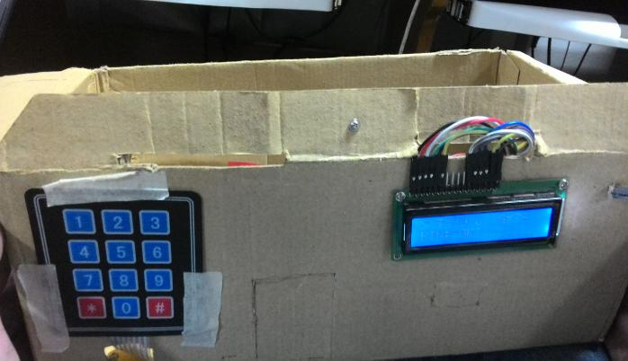

Fig 2.1

The whole system consists of two parts : one is - the door security and the other is - monitoring the home environment.

**Door Security System:** It consists of a 4x3 keypad connected with a LCD monitor and a buzzer. Both are connected to the hardware of the door lock system. The functionality is the user must put the previously set password to access the door. If the password is not matched, then the door will remain closed. The user will not get the access until he/she puts the correct password [18].

**Monitoring Home Environment:** To monitor the environment of the room, we used some sensors. Those sensors read data from the environment and shows the output in the LCD . A buzzer will alarm if there are any abnormal changes in the data. The sensors we used are - MQ-2 gas sensor , Motion PIR sensor, LM-35 temperature sensor an IR sensor. If the temperature or the gas density of the room is risen above the normal readings , the buzzer will alarm and alert people. The motion PIR and IR sensor detects any movement whenever someone enters the room[18].

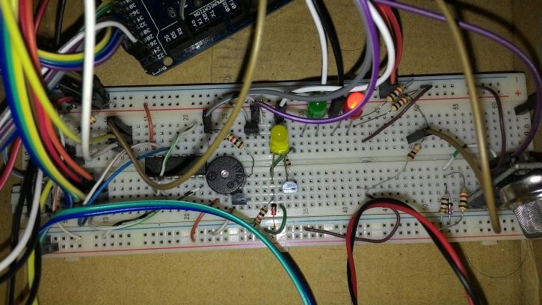

Fig 2.2

**Circuit Design:** Arduino Mega 2560 is the main processing system in the circuit. All the devices and sensors are connected to the Arduino processor. The keypad is connected with a AND 7408 and the LCD is connected with a 10K potentiometer by which we can change the contrast of the LCD. As we implemented a small model of our system, we use 3 LED in the circuit - green, yellow and red LEDs. Green will be on if the password is correct and red will burn if wrong. The yellow will burn if the motion sensor detects any moving objects.

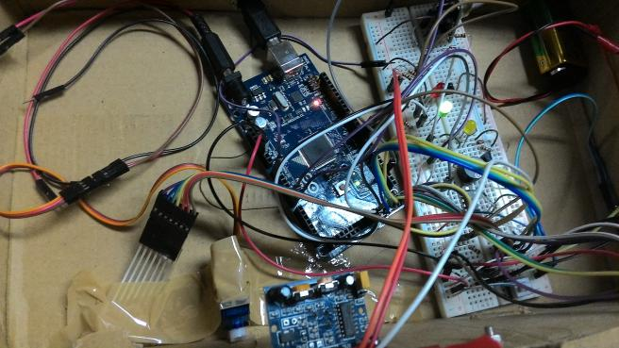

III. COMMUNICATION

The communication system is quite simple in our system. The system can communicate with the user by the display and the alarm system.

As mentioned earlier, It will trigger an alarm if the sensors find abnormal data. If the temperature rises above 50 degree celsius or the gas sensor gives a reading above 750 [14,15,18] , the buzzer will buzz continuously until the user turns it off.

The user can also interact with the keypad [16,18]. The pin number will be hidden with “*” in the display. However the user will get a “Password Accepted!” message if the password is correct and “Password Rejected!” if wrong. The “*” button acts as to erase the letters and “#” button acts as a password reset button.

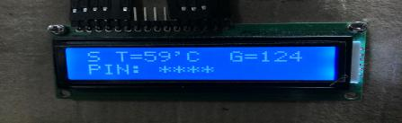

Fig 2.3

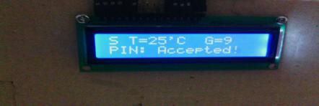

IV. COST

The cost of arduino mega 2560 is 900tk, temperature sensor costs 35tk, gas sensor costs 300 tk, motion sensor 170tk, pinpad 75tk, bread board 140 tk, resistors 100 tk, jumper wires(M-M, M-F) 200 tk, led, pot , buzzer 80 tk [3]. So in total it took 2000 tk for the whole project to build. So, the system is very affordable to all kind of people.

V. POWER SYSTEM

To power the entire system, we had used one 9V dry cell battery and a 3 cell lithium polymer battery [4,18]. We used 9v pin of the lithium polymer battery to power up out Arduino Mega micro controller and our 9v dry cell was used to power up the gas sensor science the gas sensor need higher current to operate. To connect gas sensor to dry cell we stepped down the voltage using a 5v zener diode. All other component of our system used 5V from the Arduino’s power pin. For the led’s power we used .7v diode and 100ohm resistor [4]. With the power system of ours, the whole system runs about 5 hours before lithium polymer goes out of charge and one dry cell will go about 3-5 days. On these current settings the system is not very efficient now. But, the good thing is when we will implement it in real home based system we can switch to the power supply of the house.

VI. CONTROL SYSTEM

Our system is now manually controlled. We need to set a default pin by code and without coding the user cannot change the pin current now. In future we shall implement the system so that user can give the password with verification. Similarly, our alarm system is also can be controlled manually by the user. User can switch off the alarm any time using a switch. The display brightness can be controlled by the resistor pot attached to it. To control other systems we need to change at hardware level.

VII. CAPABILITY

This security system was mainly designed to detect unauthorized entry to the house. With the pin pad our system can detect if anyone wants to give wrong pin and with 5 attempts to give incorrect pin the alarm will buzz to detect unauthorized access. Then, our motion sensor will sense any movement around the house since, there will be more than one sensor in different places of the house. So, when the house will be locked and there will be any movement in the house, the motion sensor will detect it and buzz the alarm for now. The temperature sensor and gas sensor will detect the room temperature and toxic gas limit in the house environment and if there is any increase of temperature or gas limit goes up unwillingly then the alarm will keep giving double beep to inform the house members that it is not safe in the room.

For, further implementation we want to use a bionic security system instead of pin based. We can use face detection and hand print scanner to open up the lock system. Then to detect unauthorized access in room (in case anyone breaks the door) we can use pressure sensor in front of every door and window so that, if anyone step on that and get caught. We can use CCTV camera in room to detect movement in room instead of motion sensor to increase the accuracy of our system. We also can introduce E-mail and messaging system to give the alarm alongside with the buzzer for the system to be more useful. We also can be able to detect fire situation if we use camera and temperature and gas sensor altogether. And, by implementing automated door lock system we will be able to give more efficient service in case of any unwanted situation. If we can implement these in future the system will be more useful and productive.

1. BLOCK DIAGRAM

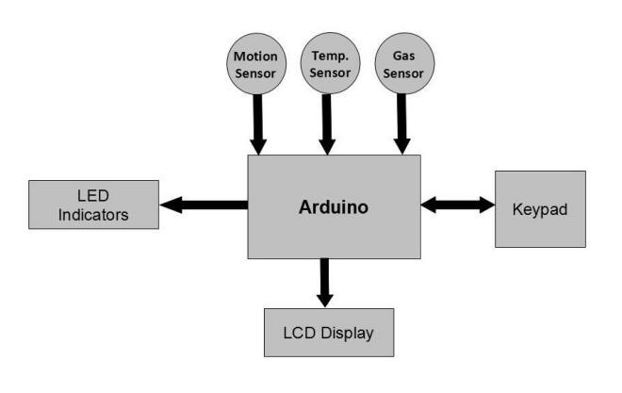

Fig: 9.1

This (Fig: 9.1) is the whole system in block diagram. The values from temperature, gas and motion sensor are directly sent to arduino mega 2560 via serial and digital ports. LEDs are also connected with the digital ports of arduino mega 2560 as well as the keypad too. The inputs are den processed by the arduino mega 2560 and converted into the output and send it to the lcd display, which is also connected with the arduino.

1. DIFFICULTIES

While trying to implementing this circuit we faced many difficulties. The main difficulty was using the interrupts pins. Enabling some interrupt pins were causing the keypad to malfunction, and sometimes was not working properly. For example, we wanted to get the result of gas sensor as soon as its ready, meanwhile we wanted to use our pin pad, but as gas sensor was calling interrupts continuously, the pin pad didn’t work. These issues were solved by the lecture [4] which was provided in the class, also some external links [5, 6, 7, 8, 11]. Another problem we faced was power, the gas sensor take more current to give accurate value. As we were using only two batteries, the gas sensor draws too much current, the battery was getting empty quite sooner and we could not supply sufficient amount of current to other sensors and devices. Also, we wanted to implement a small servo motor, but due to the lack of power supply we were unable to do so. The motion sensor was giving output for a time being and then it was restarting, so we could not manage to get continuous output. Other minor problems like coding errors were

reconciled. For example, we were getting more delay than desired. Some event handling weren’t working properly. These bugs and errors were fixed and taken care of accordingly [9, 10, 12].

1. CONCLUSION

In this paper, we have presented a system for home security, which is pin based. The total system cost around 2000tk. This system is pretty easy to design and affordable to build. There are also some implementation and upgrades that can be done with this system. An online notification system can be implemented, which can send notification if someone tries to enter forcefully to the room. Also some controls like opening the door from a distance can be implemented [13]. This system can be implemented in other accommodates like factories, garments and local business shops. Using this system in a car is also doable. In the future, we hope to make both the Pin based home security hardware designs and software openly available for others to use and to extend. Additionally, we plan on building a bigger system with more sensors.

1. ACKNOWLEDGEMENT

We are indebted to Ejaz Jamil Sir for his tremendous help during his individual interview session with the researchers of this project where he provided his valuable words for this project.

##### References

[1]https://www.arduino.cc/en/Main/ArduinoBoardMega2560

[2] https://www.sparkfun.com/categories/23?page=all

[3]<https://www.techshopbd.com/product-categories/sensors>

[4] Lectures.pdf by Ejaz Jamil Sir

[5] <http://gammon.com.au/interrupts>

[6] <https://www.arduino.cc/en/Reference/AttachInterrupt>

[7] <http://rasas.me/projects/arduino/keypad-activated-interrupt>

[8] <http://forum.arduino.cc/index.php?topic=45671.0>

[9] <http://www.geertlangereis.nl/Electronics/Pin_Change_Interrupts/PinChange_en.html>

[10] <http://www.instructables.com/answers/multiple-processes-in-arduino/>

[11] <http://www.bristolwatch.com/arduino/arduino_irq.htm>

[12] <https://www.arduino.cc/en/Tutorial/LiquidCrystal>

[13 ] <http://forum.arduino.cc/index.php?topic=8323.0>

[14] <http://www.instructables.com/id/Gas-detector-indicator-USB-powered-with-arduin/>

[15] <http://www.instructables.com/id/Arduino-Web-Server-with-sensors/step6/MQ-2-Gas-Sensor-How-to-work/>

[16] <http://www.instructables.com/id/Password-Lock-with-Arduino/>

[17] <http://www.instructables.com/id/Temperature-Sensor-Tutorial/>

[18] Datasheets provided by Ejaj Jamil Sir and from internet